MySQL Data Base for Train Ticket Booking System

Project Name: Train Ticket Booking System

Team Details:

1. Prachi Singh

2. Shailaja

3. Ibrahim

4. Saya Manish

5. Albin Jose

Project Introduction:

The MySQL train ticket booking system database is designed to manage and organize information related to train schedules, seat availability, user details, and booking records. This document provides an overview of the SQL commands required to set up and interact with the database.

Introduction to SQL:

Structured Query Language (SQL) is a standardized programming language used to manage relational databases and perform various operations data in them. Initially created in the 1970s, SQL is regularly used by database administrators and developers writing data integration scripts to set up and run analytical queries.

**Table of Contents:**

* TO CREATE A DATABASE
* TO USE A DATABASE
* TO CREATE TABLE 1 TRAIN
* TO INSERT VALUES INTO THE TABLE TRAIN
* TO VIEW THE STRUCTURE OF THE TABLE TRAIN
* TO VIEW ALL THE DATA ENTERED INTO THE TABLE TRAIN
* CREATE TABLE 2 STATION
* INSERTING VALUES IN TABLE 2 STATION
* TO VIEW TABLE 2 STATION
* TURN OFF SAFE MODE
* TO UPDATE TOTAL SEATS IN TABLE 1 TRAIN
* TO VIEW TABLE 2 UPDATED PASSENGER_DETAILS
* TO CREATE TABLE 3 SCHEDULE
* TO INSERT DETAILS IN TABLE 3 SCHEDULE
* TO VIEW DETAILS OF TABLE 3 SCHEDULE
* CREATE TABLE 4 USER
* INSERT VALUES TO TABLE 4 USER
* TO VIEW DETAILS OF TABLE 4 USER
* CREATE TABLE 5 BOOKING
* INSERT VALUES TO TABLE 5 BOOKING
* VIEW DATA OF TABLE 5 BOOKINGS
* VIEW SELECTED DATA FROM TABLE TRAIN USING WHERE KEYWORD
* VIEW SELECTED DATA FROM TABLE STATION USING WHERE KEYWORD
* VIEW SELECTED DATA FROM TABLE BOOKING USING WHERE KEYWORD
* JOINING TABLES BOOKING, USER AND TRAIN USING JOIN
* JOINING TWO TABLES TRAIN AND SCHEDULE USING JOIN

**#TO CREATE A DATABASE**

CREATE DATABASE TrainBookingSystem;

**#TO USE A DATABASE**

USE TrainBookingSystem;

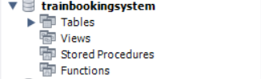

**#TO CREATE TABLE 1 TRAIN**

CREATE TABLE Train (

train_id INT PRIMARY KEY,

train_name VARCHAR(50),

total_seats INT,

available_seats INT

);

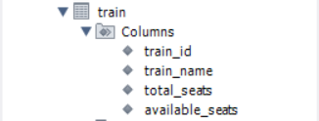

**#TO INSERT VALUES INTO THE TABLE TRAIN**

INSERT INTO Train VALUES(01, 'Train1', 20, 9),

(02, 'Train2', 30, 18),

(03, 'Train3', 40, 27);

**#TO VIEW THE STRUCTURE OF THE TABLE TRAIN**

DESC TRAIN;

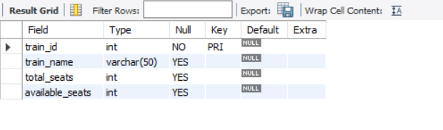

**#TO VIEW ALL THE DATA ENTERED INTO THE TABLE TRAIN**

SELECT * FROM Train;

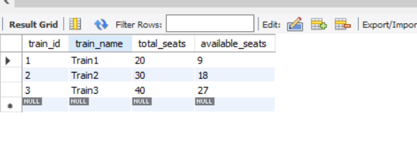

**#CREATE TABLE 2 STATION**

CREATE TABLE Station (

station_id INT PRIMARY KEY,

station_name VARCHAR(50)

);

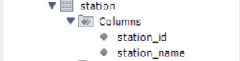

**#****INSERTING VALUES IN TABLE 2 STATION**

INSERT INTO Station VALUES(100001, 'Station1'),

(100002, 'Station2'),

(100003, 'Station3'),

(100004, 'Station4');

**#****TO VIEW TABLE 2 STATION**

SELECT * FROM Station;

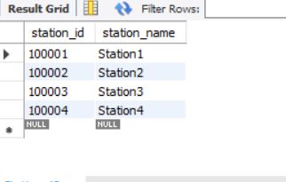

**#****TURN OFF SAFE MODE**

SET SQL_SAFE_UPDATES=0;

**#****TO UPDATE TOTAL SEATS IN TABLE 1 TRAIN**

UPDATE train

SET TOTAL_SEATS=72 WHERE TRAIN_ID=3;

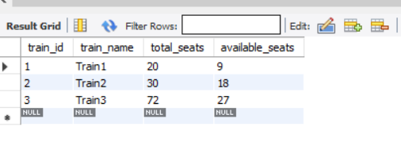

**#****TO VIEW TABLE 2 UPDATED PASSENGER_DETAILS**

SELECT * FROM TRAIN;

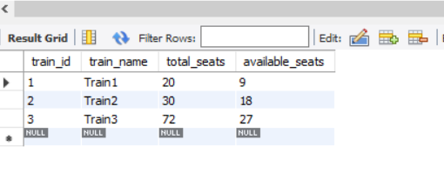

**#****TO CREATE TABLE 3 SCHEDULE**

CREATE TABLE Schedule (

schedule_id INT PRIMARY KEY,

train_id INT,

departure_station_id INT,

arrival_station_id INT,

departure_time DATETIME,

arrival_time DATETIME,

FOREIGN KEY (train_id) REFERENCES Train(train_id),

FOREIGN KEY (departure_station_id) REFERENCES Station(station_id),

FOREIGN KEY (arrival_station_id) REFERENCES Station(station_id)

);

**#****TO INSERT DETAILS IN TABLE 3 SCHEDULE**

INSERT INTO Schedule VALUES(1111, 01, 100001, 100004,'2023-05-23 19:39:44', '2023-05-24 07:40:25'),

(2222, 02, 100002, 100003,'2023-06-07 22:15:44', '2023-06-08 14:33:52'),

(3333, 03, 100003, 100001,'2023-08-19 19:39:44', '2023-08-21 07:40:25');

**#****TO VIEW DETAILS OF TABLE 3 SCHEDULE**

SELECT * FROM Schedule;

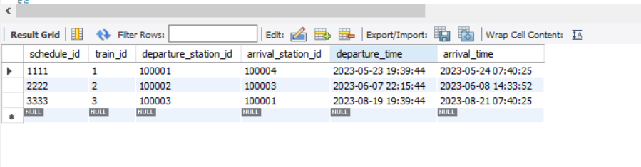

**#****CREATE TABLE 4 USER**

CREATE TABLE User (

user_id INT PRIMARY KEY,

username VARCHAR(50),

email VARCHAR(100),

password VARCHAR(100)

);



**#****INSERT VALUES TO TABLE 4 USER**

INSERT INTO User VALUES(1000, 'Prachi', 'prachi@gmail.com', 'prachi123'),

(2000, 'Shailaj', 'Shailaja@gmail.com', 'Shailaja123'),

(3000, 'Manish', 'Manish@gmail.com', 'Manish123'),

(4000, 'Ibrahim', 'Ibrahim@gmail.com', 'Ibrahim123');

**#****TO VIEW DETAILS OF TABLE 4 USER**

SELECT * FROM user;

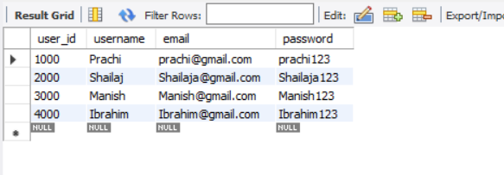

**#****CREATE TABLE 5 BOOKING**

CREATE TABLE Booking (

booking_id INT PRIMARY KEY,

user_id INT,

schedule_id INT,

booking_time DATETIME,

num_of_tickets INT,

FOREIGN KEY (user_id) REFERENCES User(user_id),

FOREIGN KEY (schedule_id) REFERENCES Schedule(schedule_id)

);

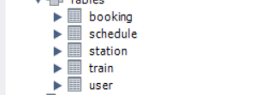

**#****INSERT VALUES TO TABLE 5 BOOKING**

INSERT INTO Booking VALUES(1, 1000, 1111, '2023-05-30 19:39:44', 5),

(2, 3000, 2222, '2023-05-21 19:39:44', 10),

(3, 4000, 3333, '2023-06-05 19:39:44', 15);

**#****VIEW DATA OF TABLE 5 BOOKINGS**

SELECT * FROM Booking;

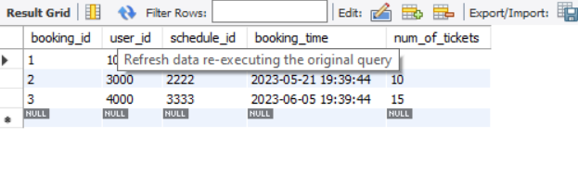

**#****VIEW SELECTED DATA FROM TABLE TRAIN USING WHERE KEYWORD**

SELECT station_name FROM Station WHERE station_id = 100001;

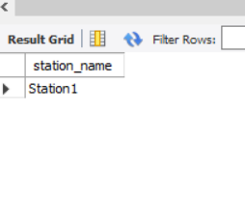

**#****VIEW SELECTED DATA FROM TABLE STATION USING WHERE KEYWORD**

SELECT * FROM Station WHERE station_id=100001;

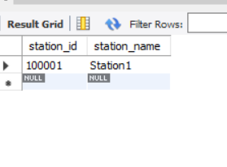

**#****VIEW SELECTED DATA FROM TABLE BOOKING USING WHERE KEYWORD**

SELECT num_of_tickets FROM Booking WHERE booking_id = 2;

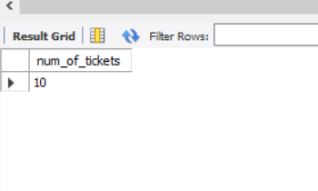

**#****JOINING TABLES BOOKING, USER AND TRAIN USING JOIN WHICH DISPLAYS THE DATA AS BOOKING IS THE TABLE WHICH IS RELATED TO USER TABLE , TRAIN TABLE AND SCHEDULE TABLE WITH USER_ID BEING PRIMARY KEY IN USER LINKED IN BOOKING TABLE USING FOREIGN KEY, SCHEDULE_ID BEING PRIMARY KEY IN SCHEDULE AND LINKED TO BOOKING TABLE USING FOREIGN KEY AND TRAIN_ID BEING A PRIMARY KEY IN TRAIN TABLE AND LINKED TO SCHEDULE USING FOREIGN KEY**

SELECT

User.username,

Train.train_name,

Schedule.departure_time,

Schedule.arrival_time,

Booking.num_of_tickets,

Booking.booking_time

FROM Booking

JOIN User ON Booking.user_id = User.user_id

JOIN Schedule ON Booking.schedule_id = Schedule.schedule_id

JOIN Train ON Schedule.train_id = Train.train_id;

**#IT SHOWSUSER_NAME FROM USER, TRAIN_NAME FROM TRAIN TABLE, DEPARTURE_TIME FROM SCHEDULE TABLE, ARRIVAL_TIME FROM SCHEDULE TABLE, NUM_OF_TICKETS FROM BOOKING TABLE AND BOOKING_TIME FROM BOOKING TABLE**

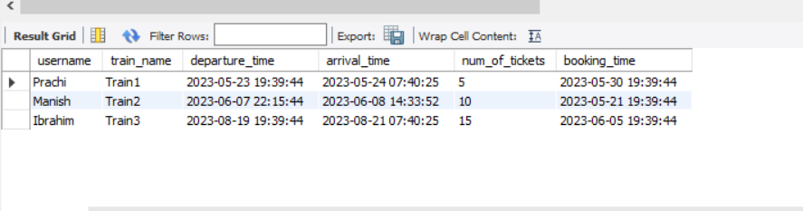

**#****JOINING TWO TABLES TRAIN AND SCHEDULE USING JOIN WHICH DISPLAYS THE DATA USING WHERE KEYWORD. TRAIN_NAME IS THE PRIMARY KEY IN TRAIN TABLE WHICH IS ALSO LINKED TO SCHEDULE TABLE USING FOREIGN KEY**

SELECT

Train.train_name,

Schedule.departure_time,

Schedule.arrival_time

FROM Train

JOIN Schedule ON Train.train_id = Schedule.train_id

WHERE Schedule.departure_time = '2023-05-23 19:39:44' AND Schedule.arrival_time = '2023-05-24 07:40:25';

**#IT SHOWS TRAIN_NAME FROM TRAIN TABLE, DEPARTURE_TIME FROM SCHEDULE TABLE, ARRIVAL_TIME FROM SCHEDULE TABLE**

